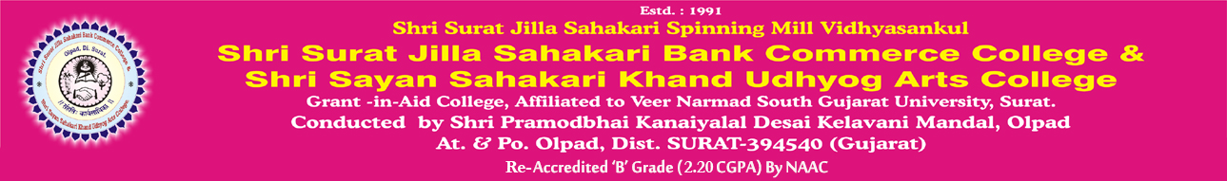

Vision:

- “To provide knowledge based, career oriented quality education in various disciplines and innovative learning practices to develop multi-dimensional personality of students and build better citizens for tomorrow”.
Mission:
  - To groom a student in areas of his/her career of interest and impart necessary competence to make one successful in professional career.
  - To start various educational courses for academic, co-curricular and overall development of students and staff.
  - To bring continuous improvement in performance on basis of the feedback from all the stake holders (Students, Parents, Faculty, management, employers, concerned authorities).
  - To build resource pool of alumni, ex-staff, donors and well-wishers.

